[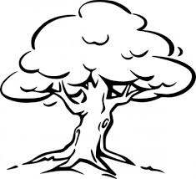](http://www.google.com.au/url?sa=i&rct=j&q=&esrc=s&source=images&cd=&cad=rja&uact=8&docid=Q-jachXC6K5l9M&tbnid=dEZcnnM6t4ztbM:&ved=0CAUQjRw&url=http://all-free-download.com/free-vector/vector-clip-art/tree_outline_clip_art_11785.html&ei=gkD1U_q5CIzp8AXO4oLQAQ&bvm=bv.73231344,d.dGc&psig=AFQjCNFOn96papxJpTkYcyqtzYCWu8mjvQ&ust=1408668120729314)Investigating and Earth Science Year 8

End of Topic Test

Name: _______________________________________ Total: 70 marks

Part A: Multiple-Choice (10 marks)

1. Which of the following is **not** a type of sedimentary rock?

**A** clastic.

**B** plastic.

**C** chemical.

**D** organic.

2. Which of the following statements is **not** true about sedimentary rocks?

**A** they form from cooling magma.

**B** they can contain fossils.

**C** they can have layers.

**D** they can contain crystals.

3.Which of the following are **all** sedimentary rocks?

**A** sandstone, limestone, mudstone, conglomerate and basalt.

**B** sandstone, limestone, mudstone, conglomerate and breccia.

**C** limestone, breccia, conglomerate, granite and siltstone.

**D** granite, pumice, conglomerate, basalt and gneiss.

4. The formation of sedimentary rocks in the rock cycle involves:

**A** weathering and erosion of other rocks first.

**B** heat and/or pressure.

**C** cooling of magma.

**D** melting of other rocks.

5. Which of the following is **not** true about **metamorphic rocks**?

**A** they form from heat and/or pressure.

**B** they can contain precious gems such as sapphires.

**C** they never contain crystals.

**D** gneiss, marble, slate and schist are all examples of metamorphic rock.

6. Which of the following is **not** correct in the formation of metamorphic rocks?

**A** limestone becomes marble.

**B** sandstone becomes quartzite.

**C** granite becomes gneiss.

**D** conglomerate become basalt.

7. The **dependent** variable is:

**A** the variable you measure or observe.

**B** the variable you keep the same.

**C** the variable you change.

**D** all of the above.

8. Which piece of equipment would be used to measure exactly 27ml of a liquid?

**A** beaker.

**B** measuring cylinder.

**C** conical flask.

**D** test tube.

9. The main physical properties used to identify minerals are:

**A** hardness, shininess, prettiness and colour.

**B** hardness, lustre, size and streak.

**C** hardness, lustre, price and colour.

**D** hardness, lustre, colour and streak.

10. Which graph would you use for a set of individual data, such as shoe brands people prefer?

**A** column or bar.

**B** pie.

**C** line.

**D** none of the above.

**Part 2: Short Answer** (60 marks)

1. **Match** the following terms with their correct meaning. Note: not all words will be used.

Fossil, sedimentary rock, metamorphic rock, heat and/or pressure, cementation, compaction, weathering, erosion, limestone, sandstone, breccia, conglomerate, coal, foliation, rock cycle, minerals, hardness, streak, lustre, mohs, beaker, Bunsen burner, tongs, tripod.

a) How shiny a mineral is _____________________________________________________

b) The endless cycle of change that rocks undergo __________________________________

c) The remains of a plant or animal found in a rock _________________________________

d) A scale used to measure hardness in minerals ___________________________________

e) Used to pick up hot objects __________________________________________________

f) A sedimentary rock made from plant matter _____________________________________

g) A rock that forms from the cementation and compaction of weathered and eroded rock

pieces ___________________________________________________________________

h) Process that form metamorphic rocks __________________________________________

i) Used to heat things in a laboratory ____________________________________________

j) A sedimentary rock made of rounded pieces of rock stuck together __________________

________________________________________________________________________

(10 marks)

2. **Draw** and **label** a diagram of the rock cycle:

(5 marks)

3. a) **Describe** how lustre and streak are different:

___________________________________________________________________________

___________________________________________________________________________

___________________________________________________________________________

___________________________________________________________________________

(2 marks)

b) **Explain** why fossils are not generally found in metamorphic rocks:

___________________________________________________________________________

___________________________________________________________________________

___________________________________________________________________________

(2 marks)

4. a) **List** three sedimentary rocks ________________________________________________

1. **List** two characteristics of a sedimentary rock ___________________________________

_______________________________________________________________________

_______________________________________________________________________

1. **List** two metamorphic rocks ________________________________________________

_______________________________________________________________________

_______________________________________________________________________

(3 marks)

5. **Justify** the following statement: *Metamorphic rocks can form from both heat and pressure, therefore, they don’t always have to form deep in the Earth.*

___________________________________________________________________________

___________________________________________________________________________

___________________________________________________________________________

(2 marks)

6. **Explain** how colour is different to lustre: _________________________________________

___________________________________________________________________________

___________________________________________________________________________

(2 marks)

7. **Classify** the following as sedimentary or metamorphic:

1. limestone ___________________________________________________
2. conglomerate ________________________________________________
3. marble ______________________________________________________
4. gneiss ______________________________________________________

(4 marks)

8. **Identify** the following minerals using Mohs scale:

1. On testing, topaz scratched an unknown mineral, but feldspar did not. State the mineral.

|  |  |
| --- | --- |
| Hardness | Mineral |
| 1 | Talc |
| 2 | Gypsum |
| 3 | Calcite |
| 4 | Flourite |
| 5 | Apatite |
| 6 | Feldspar |
| 7 | Quartz |
| 8 | Topaz |
| 9 | Corundum |
| 10 | Diamond |

__________________________________________

b) On testing, nothing could scratch the mineral. State the

mineral.

­­____________________________________________

c) On testing the mineral could be scratched by all the

minerals. State the mineral.

_____________________________________________

(3 marks)

9. The following is the hardness of a range of minerals and objects.

|  |  |
| --- | --- |
| **Mineral or Test Object** | **Hardness** |
| Talc | 1 |
| Gypsum | 2 |
| Calcite | 3 |
| Flourite | 4 |
| Apatite | 5 |
| Feldspar | 6 |
| Quartz | 7 |
| Topaz | 8 |
| Corundum | 9 |
| Diamond | 10 |
| Fingernail | 2.5 |
| Copper washer | 4 |
| Cast iron | 4.5 |
| Window glass | 5.5 |
| Steel knife | 6 |

a) Graph the results above as a column graph. (6 marks)

b) Which mineral or object has the highest hardness? ___________________________

(1 mark)

c) **Estimate** the hardness of something that can be scratched by apatite but not cast iron?

­­­­­­­­­_____________________________________________________________________

(1 mark)

d) **Compare** the hardness of fluorite and a copper washer ________________________

_____________________________________________________________________

(2 marks)

e) **Estimate** the hardness of something that can be scratched by feldspar and a glass window but not apatite__________________________________________________

(1 mark)

f) **Estimate** the hardness of something that can be scratched by corundum but not by quartz.

____________________________________________________________________

(1 mark)

g) **Explain** why the above estimate may not necessarily be accurate ________________

____________________________________________________________________

_____________________________________________________________________

_____________________________________________________________________

_____________________________________________________________________

(2 mark)

10. **Define** the following:

i) Metamorphic rock _____________________________________________________

___________________________________________________________________________

ii) Foliation _____________________________________________________________

___________________________________________________________________________

iii) Crystallization ________________________________________________________

___________________________________________________________________________

iv) Clastic sedimentary rock ________________________________________________

___________________________________________________________________________

(4 marks)

12. **State** the amount in each box below:

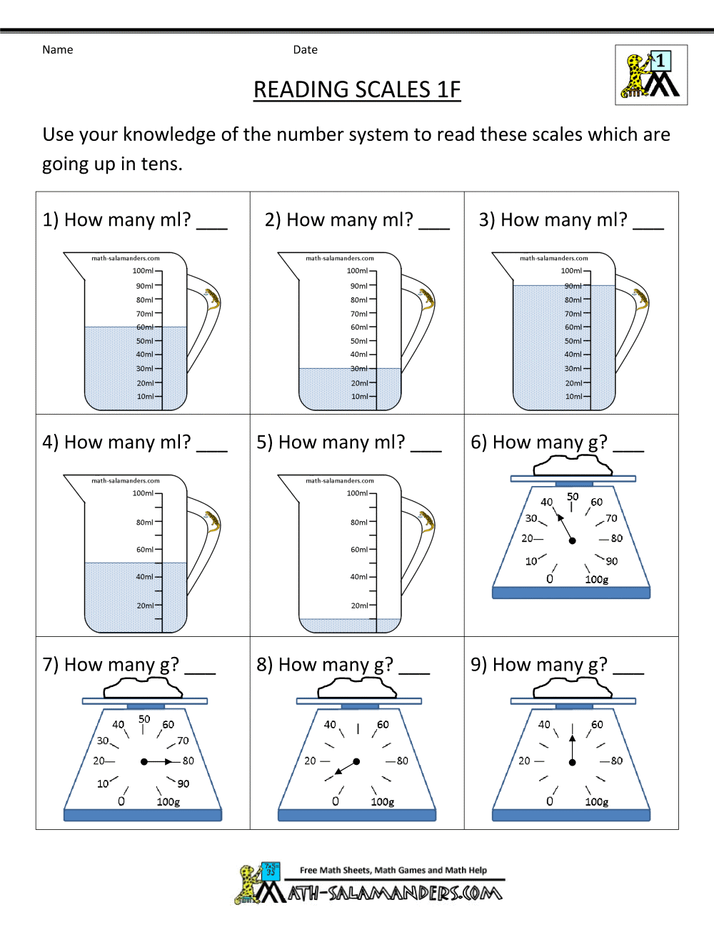

(9 marks)